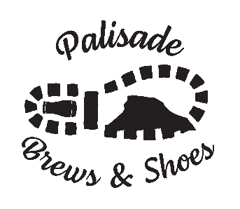
PALISADE CHAMBER OF COMMERCE
BREWS & SHOES PRESENTED BY GRAND VALLEY BANK
VOLUNTEER PARTICIPATION AND WAIVER OF LIABILITY FORM

Instructions for Completing Your Form:
Volunteer assignments are made on a first-come, first-serve basis. You will receive your assignment by email. Volunteers who want to work together should indicate on your form, but each volunteer must complete their own application.
Volunteers can specify a choice of assignment and shift below: set up, ID checking (must be 21+), gate, tear down.
Volunteers should arrive 30 minutes before scheduled time to check in.
Volunteers receive a tasting mug and free sampling wristband.

Name: ____________________________________

Address: __________________________________

City: ______________________________________ | State: _____ | Zip:________
Phone (best #): _____________________

Email: ______________________________________________

ASSIGNMENT DAY / TIME / AREA:
Saturday, MAY 14th 8:30 AM – 6:30 PM MEMORIAL PARK

SHIFT 1: 8:30AM – 11:30AM – SET UP
SHIFT 2: 11:30AM-2:30PM GATE
SHIFT 3: 2:30PM – 5:30PM GATE
SHIFT 4: 5:00PM-6:30PM TEAR DOWN
Choice of Assignment: _____________________________
Choice of shift: _______________________________

WAIVER OF LIABILITY:
Waiver of Liability: By submitting the Volunteer Application form, volunteer agrees to bear full responsibility and full liability for any and all damage or injury which might result from volunteering at this event. Volunteer also releases and agrees to hold harmless and indemnify the staff and directors of Palisade Chamber of Commerce (PCOC), event sponsors and their insurance carriers from any and all claims, actions or damages without any limitation whatsoever, whether consisting of personal injury, property damage or death that results in any way from any act of the volunteer while attending or volunteering at the Brews & Shoes Presented by Grand Valley Bank Event.
You MUST check the item below and sign for your request to be processed:
❍ I have read the 2022 Waiver of Liability.

Signature:

Please return form via fax to 970-464-4757 or email to info@palisadecoc.com

